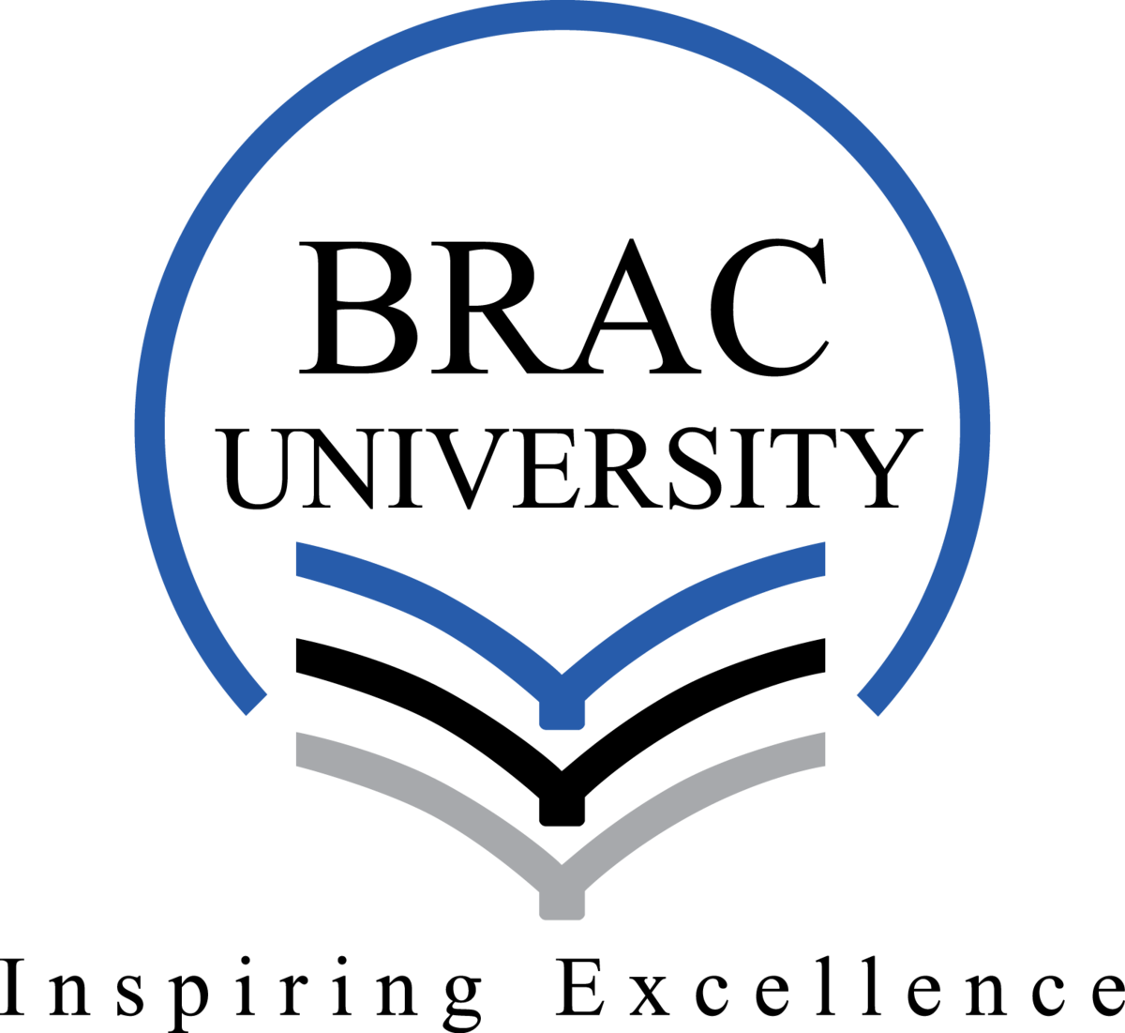

Hum101 Reflection Paper

Name: Tahsin Raihan Robbani
Id: 22201344
Section: 11

Reflection Paper on the Final Project: Creating an Academic Poster on Troy and Shadow

Introduction

I have thoroughly enjoyed working on this group work. It gave me the chance to learn the subjects of religion and mythology in ancient cultures. When we picked the films Troy and Shadow, I wasn’t sure how to do analyzing such different films. But when we started collaborating, I saw that both movies provided detailed descriptions of how ancient societies saw leadership, combat. Troy reflects the Greek obsession with heroism and divine intervention and Shadow explores the use of deception and strategy in the context of power.

Initial Steps and Group Collaboration

We divided the work equally from the start, with each individual working on a distinct aspect of the poster. Our first assignment was to watch both movies on our own. It helped us in creating our own review of both films. That was the start of our main work. From the very start, I faced the challenge of balancing academic analysis with visual design. I was the person in charge of studying the religious and mythological analogies in the movies. But I found myself digging deeply into the cultural and historical backgrounds of both Shadow and Troy. The challenge was deciding which materials to use specifically for the poster's visuals. I tried to incorporate a lot of detail at first, but I quickly realized that this was not the greatest strategy for a poster that needed to be concise and appealing. Choosing the appropriate emphasis for the examination of both movies was another difficulty. The Greek gods' involvement in human affairs, heroism, and divine intervention are all featured in Troy. On the other hand, Shadow is more difficult to connect to religion since it has intentional deception and power dynamics rather than directly involving god. It was tough to connect this films with the course’s theme.

Poster Creation and Design Process

We started working on the academic poster's real design after deciding on our theme and content.. This part of the project was both challenging and enjoyable. I completed the design portion using Adobe Illustrator. But without constant assistance from my group members I could never make it visually appealing. We needed to make sure that the visual elements made sense. It was important for us to create a balance between the academic content and the film’s story. We used images of Achilles, Hector, and other characters to demonstrate the mythological influence and their actions. Throughout this process, I learned how to maintain the integrity of the academic argument and how to present complicated concepts in an eye-catching manner.

Critiquing Our Group Work and Collaboration Dynamics

All of our member worked very hard for the project. They tried their using their expertise. But as it is a group work obviously there will be difficulties. We stared facing difficulties when we were merging our ideas and thoughts of both movies. Another we didn’t communicated much on how we wanted the poster to look. So that created a problem as well. Some of the members were prioritizing the visual look keeping the academic content bookish. This lead to a struggle what to present what to not. But we gave our best effort and in the end it came out great. Every member suggestion and criticism may have created a small clash among us but at the very end this collaboration made our work better.

Reflections on My Personal Contribution and Learning

I believe I did a good job in the initial study for both films based on my contributions. As I’m from CSE background these topic was not easy at all. However, I focused mainly on detailed explanations and it this made harder for the information to fit neatly into the design. At certain points during the project, I questioned whether working alone would have been simpler. It was occasionally challenging to keep everyone happy at the same time. But when I think back on the entire process, I think the group interaction made a significant contribution to the project's overall quality. Our project analysis was improved by the range of perspectives. Though there were difficulties but our members really made it very perfect with their knowledge and thoughts .

Conclusion

This project taught me the importance of maintaining academic lessons with creative design. I realized that visual elements are essential in an academic poster and they help convey complex ideas clearly. Personally, I learned that group work requires flexibility and clear communication. It was challenging to implement our idea. But this project helped me develop better group work and analyzing skills. I also learned how to accept and use constructive criticism to improve my work. In conclusion, this project was a valuable learning experience for both my research and teamwork abilities. The challenges were not easy, but the final product was stronger for our collective effort. The lessons I’ve learned will guide me in future projects many other group work .

